

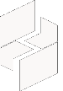

MICROSOFT ARCHITECTURE BEST PRACTICE FOR CLOUD AI PLATFORM

USECASE: GITOPS FOR AZURE KUBERNETES SERVICE

Document Title | Microsoft Cloud Center of Excellence Overview
Presales/Technical Head | Tushar Mehrotra/Rohit Pandey
CCoE Lead | Ravishankar N
Creation Date | December 2025
Version | Description | Modified by | Date | Approved by | Date
1 | Initial Architecture design | Ranu Kumar | 15/12/2025 | Ravi Shankar | 15/12/2025
Contents
1
1. Executive Summary 3
2. Scope and Applicability 3
3. Business Scenario Overview 3
4. Reference Architecture Overview 4
4.1 Architecture Description 4
5 Logical Architecture Components 4
5.1 Source Control and Configuration Repositories 4
5.2 GitOps Operators and Controllers 5
5.3 Continuous Deployment Workflow 5
6 Architectural Best Practices 6
6.1 Git as the Source of Truth 6
10 Conclusion 7

Baseline architecture for an Azure Kubernetes Service (AKS) cluster

Executive Summary
This document describes a standardized GitOps-based reference architecture for Azure Kubernetes Service (AKS) and outlines best practices for implementing continuous deployment, configuration management, and operational governance using Git as the single source of truth.
The architecture is curated and maintained as an internal platform standard to enable consistent, secure, and scalable Kubernetes operations across environments while improving deployment reliability and auditability.

Scope and Applicability
This reference architecture applies to:
- AKS-based application platforms adopting GitOps practices
- Continuous deployment and configuration management scenarios
- Microservices and cloud-native application workloads
- Multi-environment Kubernetes deployments (development, test, production)
- Teams seeking improved operational consistency and traceability
The design is suitable for enterprise and mid-market environments and can be adapted to different organizational operating models and compliance requirements.

Business Scenario Overview
As Kubernetes platforms scale, managing configuration drift, deployment consistency, and operational transparency becomes increasingly complex. Traditional imperative deployment approaches often lead to manual intervention, reduced traceability, and increased operational risk.
Adopting a GitOps operating model for AKS enables organizations to:
- Use Git repositories as the authoritative source for cluster and application state
- Automate deployments through declarative configuration
- Improve traceability, change control, and rollback capabilities
- Enforce consistent configuration across environments
- Support scalable, team-based Kubernetes operations

Reference Architecture Overview

Architecture Description
The GitOps-based AKS architecture introduces a clear separation between deployment intent (stored in Git repositories) and runtime state (enforced within the Kubernetes cluster). Automated agents continuously reconcile the desired state defined in Git with the actual state of the cluster.
High-Level Architecture Description
- Application and platform configurations are stored declaratively in Git repositories
- Git remains the single source of truth for desired system state
- GitOps operators run within the AKS cluster
- Operators continuously synchronize cluster state with Git
- Changes are applied automatically through pull request-driven workflows
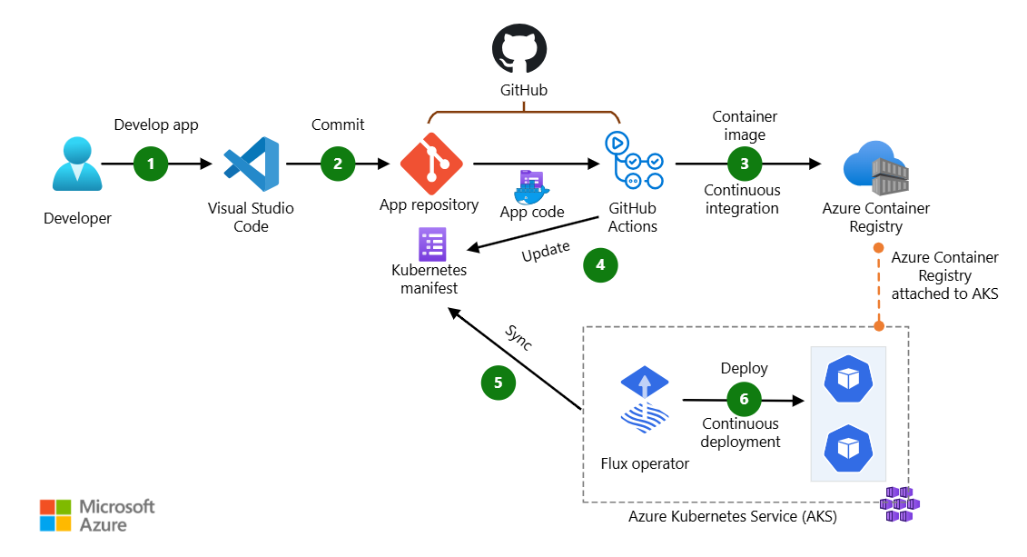

Logical Architecture Components

Source Control and Configuration Repositories
Git repositories host all declarative configuration required to operate the platform, including:
- Kubernetes manifests and templates
- Application deployment definitions
- Environment-specific configuration overlays
- Platform and cluster-level configuration
Repository structure is designed to clearly separate application concerns from platform concerns.

GitOps Operators and Controllers
GitOps operators are deployed within the AKS cluster to enforce the desired state defined in Git. Key responsibilities include:
- Monitoring Git repositories for changes
- Validating and applying configuration updates
- Reconciling drift between desired and actual state
- Reporting deployment and synchronization status
This model ensures that all changes flow through version-controlled and auditable processes.

Continuous Deployment Workflow
Deployment workflows follow a declarative, pull request-driven model:
- Changes are proposed via pull requests
- Reviews and approvals enforce governance controls
- Merged changes are automatically reconciled into the cluster
- Rollbacks are performed by reverting Git commits
This approach provides predictable and repeatable deployments across environments.
Application Runtime – Azure Kubernetes Service
AKS provides the managed Kubernetes runtime for applications. Within this architecture:
- Multiple node pools support different workload profiles
- Applications are deployed using declarative Kubernetes resources
- Runtime scaling and self-healing are handled by Kubernetes controllers
- GitOps tooling focuses exclusively on desired state enforcement
Identity, Access, and Security
Security is integrated throughout the GitOps architecture:
- Access to Git repositories is controlled using enterprise identity services
- Role-based access control governs changes to configuration repositories
- Cluster access is minimized and granted only where required
- Secrets and sensitive configuration are managed using secure services
This model reduces direct cluster access and strengthens security posture.
Observability and Operations
Operational visibility is achieved through:
- Monitoring deployment health and synchronization status
- Centralized logging and metrics for platform and applications
- Alerts for failed reconciliations or configuration drift
- Dashboards that provide insight into deployment pipelines
These capabilities support proactive operations and rapid issue resolution.

Architectural Best Practices

6.1 Git as the Source of Truth
- Store all deployment and configuration state in Git
- Avoid manual changes directly in clusters
- Enforce pull request-based change workflows

6.2 Resilience and Reliability
- Design operators to reconcile continuously and recover from failures
- Test changes in lower environments before promotion
- Use rollback mechanisms based on Git history

Conclusion
The GitOps-based AKS reference architecture described in this document provides a scalable, auditable, and automation-driven approach to operating Kubernetes platforms on Azure. By standardizing on declarative configuration and Git-centric workflows, organizations can improve deployment consistency, operational reliability, and overall platform governance.

